Data Interpretation Warm-Up Activity

Purpose: Purpose: Students will describe their understanding of interpreting the data from a graph.

Teacher Instruction:
- Choose the same graph below that you chose for data analysis. You may also use the graph that you showed previously.
- Show students the graph and have them respond to 1 question through a google form you created and shared with them. CLICK HERE FOR A SAMPLE FORM.
- Look at each student’s response and give it a score: a check if they answered the question correctly, an x if they answered the question incorrectly or a question mark if you are not sure.
- Total the number of checks, x’s and ? by either period or total number of students.
- Communicate your numbers to Tracy.
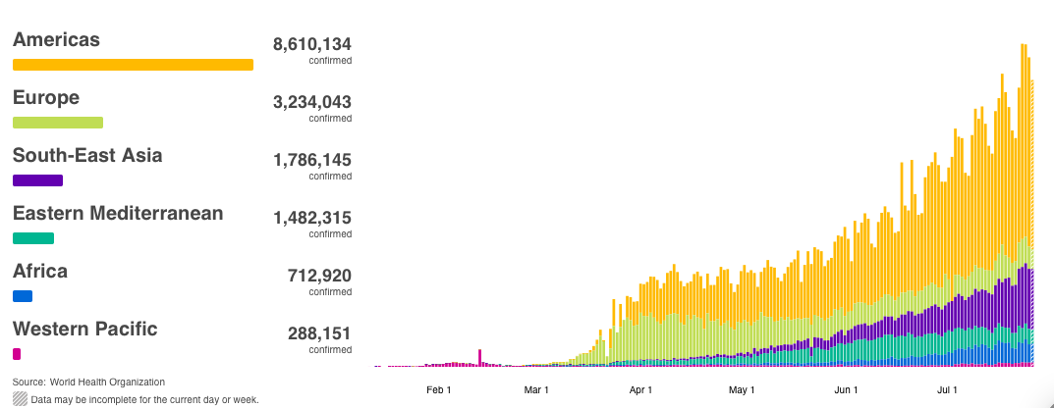
Confirmed COVID Cases by Region

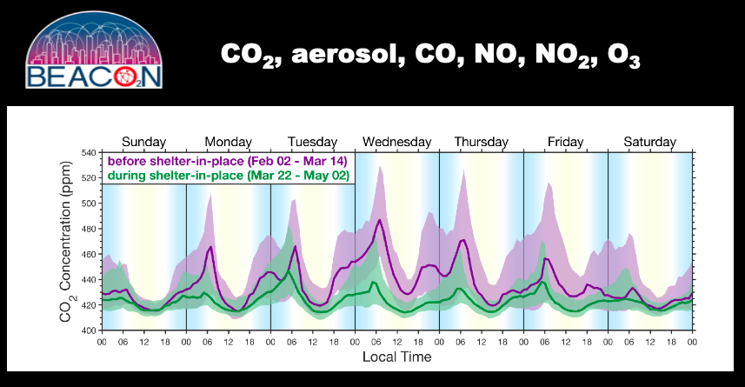

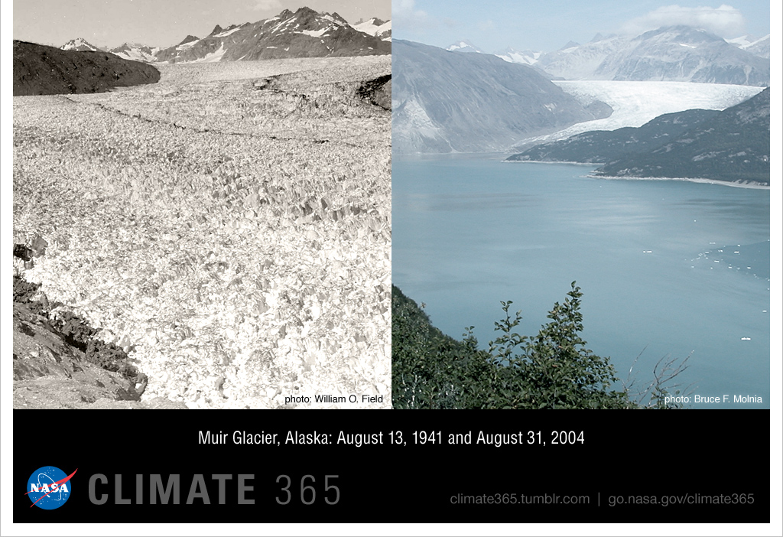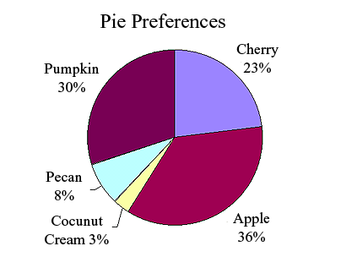
1920
2020

Student Warm-Up Question
Name ___________

Question:
- What question do you think the graph/picture is answering?
(Sample answers:)
- How do are COVID cases distributed globally from January – July 2020? (distribution) Data Interpretation
- How did air quality change before and during shelter in place? (comparison) Data Interpretation
- How did the glacier change in size in the past 100 years? (comparison) Data Interpretation
- What are the pie preferences of the students according to the chart? (composition) Data Interpretation

