Pre-Data Analysis Warm Up Activity

Purpose: Students will describe their understanding of data variables and summarizing data from a graph.

Teacher Instruction:
- Choose one of the graphs below to show your students. You may also choose a graph of your own.
- Show students the graph and have them respond to 1 question through a google form you created and shared with them. CLICK HERE FOR A SAMPLE FORM.
- Look at each student’s response and give it a score: a check if they answered the question correctly, an x if they answered the question incorrectly or a question mark if you are not sure.
- Total the number of checks, xs and ?s by either period or total number of students.
- Communicate your numbers to Tracy.

Graph Choices:
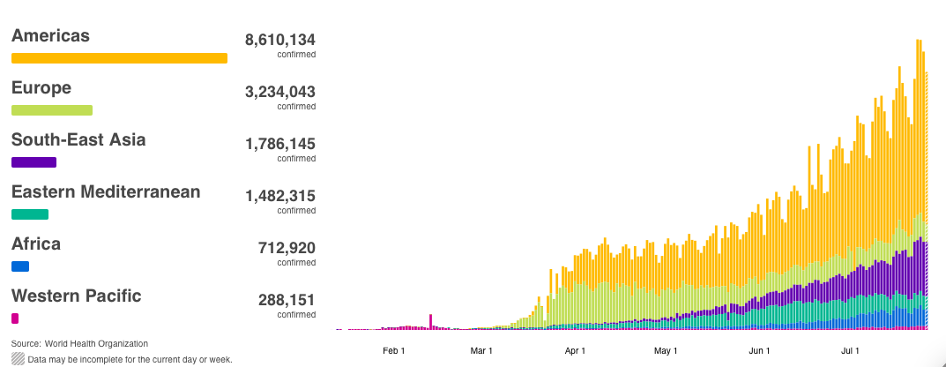
Confirmed COVID Cases by Region

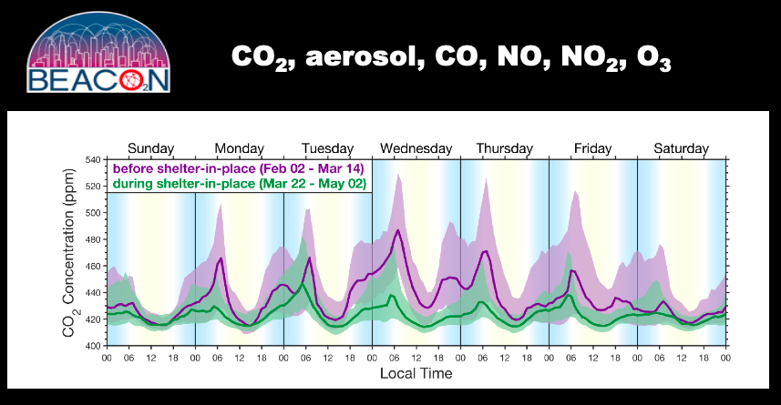

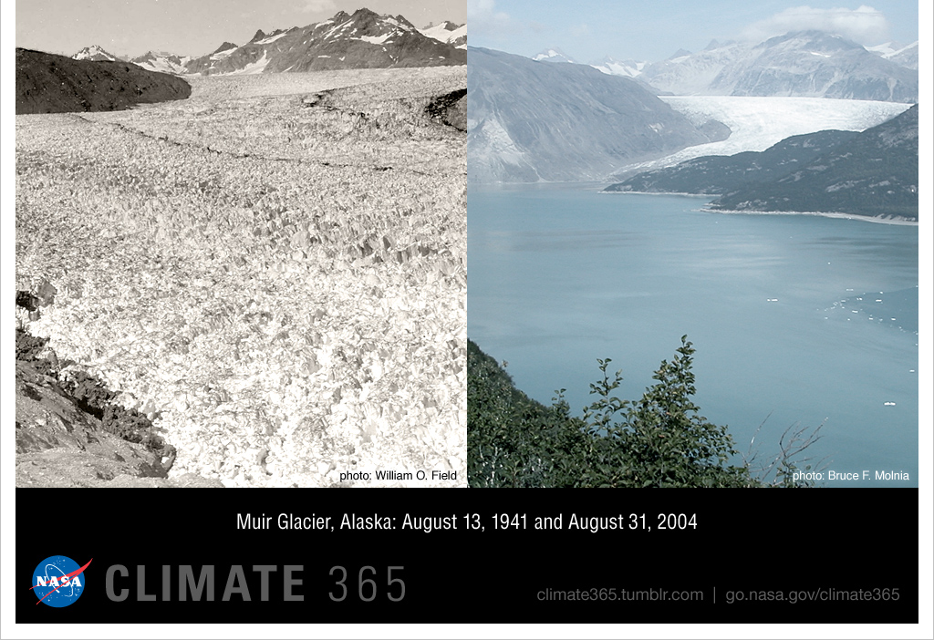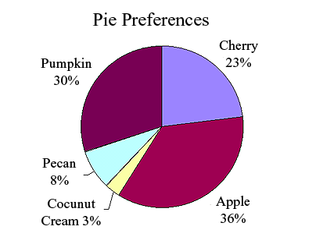
1920
2020

Student Warm-Up Question
Name ___________

Question:
- Identify the data variables expressed in the graph/picture and state the “story the data are telling”

(Answers will vary but data variables include: COVID: dates, regions, number of cases, AIR QUALITY: CO2 concentration, days of the week, time, GLACIER PICTURE: amount of glacier, date, PIES: types of pies, % of pies, Answers will vary but the story has to “match” the picture. They should write a sentence about the story the visual is telling without drawing a conclusion. Data Analysis

