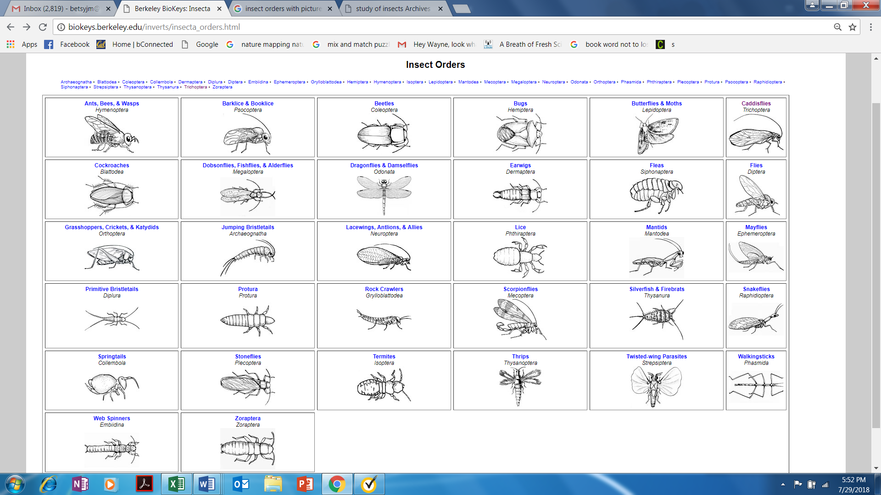Berkeley Biokeys -- <http://biokeys.berkeley.edu/>