[](https://www.organiclesson.com/)

**5 Animals that Have an Unusual Seed Dispersal Role**

https://www.organiclesson.com/animals-seed-dispersal-plant-preservation/

Article on [General](https://www.organiclesson.com/category/general/)

If there’s one thing you may still remember from your high school biology class, it may be the ways that plant disperse their seeds. Whether that’s through wind, water, or by tagging along to an animal, seed dispersal is crucial to the survival of plants. With animals, researchers have uncovered a number of unusual suspects that play a very important role in dispersing the seeds of native plant species. We aren’t talking about birds or bees. Here are five animals that you wouldn’t think of first-hand when it comes to seed dispersal.

**Cougars**

It is very unusual to think of cougars as being very good at dispersing seeds because they are super-carnivorous predators on the top of the food chain. Well, researchers found that cougars in Argentina actually help seed dispersal [1]. They do this by eating prey like Eared Doves. Eared doves eat seeds from the ground. When the cougars eat the doves, the seeds go along with them. The seed dispersal happens as the cougar roams the jungle and drops a scat here and there. The seeds in the scat can sprout in their new place! Cougars are very good dispersing animals because they travel long distances. According to one study, cougars could plant around 94,000 seeds in a year!



Can you think of an animal in your neighborhood that disperses seeds?

**Elephants**

It might not be surprising that since elephants are one of the largest frugivores (fruit eaters) on the planet they play an important role in dispersing the seeds of native plants across long distances. Researchers collected and analyzed elephant dung (those poor souls) and found many seeds They found that seeds were being disseminated by the Congo forest elephants across distances of 24 – 57 kilometers [2]. Of the 855 Congo elephant dungs they analyzed, 800 (94%) of them had seeds in them! Those seeds came from 73 different kinds of trees.

Well, there you have it. Dung, poop, feces, manure, whatever you like to call it, plays an important role in seed dispersal. Some animals that disperse seeds are becoming or are already endangered species. We have an important part to play to ensure the survival of those species, which in turn, helps the ecosystem in ways we haven’t always imagined before.

Can you think of an animal in your neighborhood that disperses seeds?

**Ants**

They are very strong for their size. Did you know that ants can carry up to 5,000 times their own body weight? [3] With such great strength, carrying seeds is a piece of cake for them. There is even a term for this: Myrmecochory. It is a big fancy word just that – seeds dispersed by ants. Myrmecochory is very important in nature. The ant helps the seed and the seed also helps the ant! How does that work you might ask. It all starts when ants take the seeds back to their colonies. These seeds have special parts called elaisomes. The elaisome is a soft fleshy blob attached to the seed. It helps the ants because it is packed with proteins and oils and is very good food for them. When an ant finds a seed, it takes it back to its nest. It eats the elaisome. When the ant is done eating the elaisome, it throws the seed away into a new area where the seeds can germinate. Sounds like a win-win for both.

Well, there you have it. Animals can move seeds by carrying them. They also can carry it in their belly -- dung, poop, feces, manure, whatever you like to call it, plays an important role in seed dispersal. Some animals that disperse seeds are becoming or are already endangered species. We have an important part to play to ensure the survival of those species, which in turn, helps the ecosystem in ways we haven’t always imagined before.

Can you think of an animal in your neighborhood that disperses seeds?

**Fishes**

Yes, some fish help to disperse seeds! Researchers went to the Pantanal in Brazil. The Pantanal is a special wetland area that floods during the rainy season every year. Here they found a fish called the Pacu. It is a relative of the Pirana and has very sharp teeth. These sharp teeth allow them to munch away at fruits that fall into the water. In the rainy season when the rivers flood into the forest, lots of fruits fall into the flood water. The Pacus eat them. As you may guess, the seeds go into the stomach and intestines of the fish and are carried along as the fish moves around in its habitat. Sooner or later, the Pacu will poop out the seed in a new place where it can sprout. These Pacu fish can move seeds of tropical forest plants very long distances!

Well, there you have it. Dung, poop, feces, manure, whatever you like to call it, plays an important role in seed dispersal. Some animals that disperse seeds are becoming or are already endangered species. We have an important part to play to ensure the survival of those species, which in turn, helps the ecosystem in ways we haven’t always imagined before.

Can you think of an animal in your neighborhood that disperses seeds?

**Lizards**

Researchers in New Zealand found that lizards help to disperse the seeds of native berries. How? The lizards eat the berries, seeds and all, but the seeds don’t get digested. Later, when the lizard poops, outcome some of the seeds. Many of those seeds survive passing through the gut of the lizard and can sprout! So, the lizard ate the berries with seeds, moved to another place carrying the seeds in its belly, and then pooped the seeds out in another place! And it gets even better. The lizards often poop in small rocky crevices [5]. Rocky crevices are very good habitat for those sprouting seeds, so the seeds that the lizards disperse have a very good chance of surviving.

Well, there you have it. Dung, poop, feces, manure, whatever you like to call it, plays an important role in the seed dispersal process. Some animals that disperse seeds are becoming or are already endangered species. We have an important part to play to ensure the survival of those species, which in turn, helps the ecosystem in ways we haven’t always imagined before.

Can you think of an animal in your neighborhood that disperses seeds?

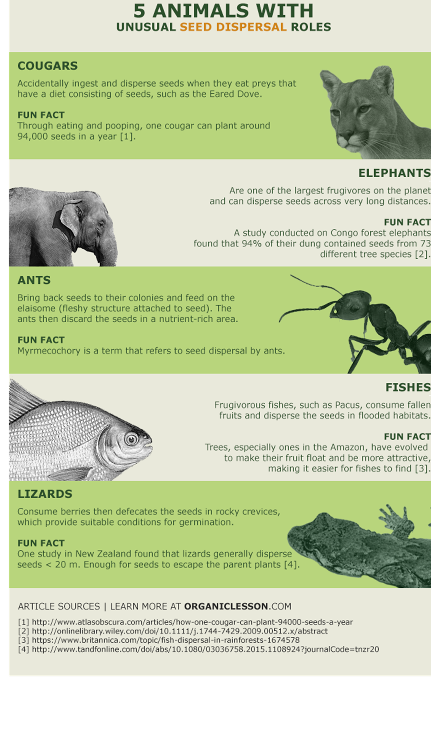

**Article Sources**  
[1] http://www.nature.com/articles/srep19647  
[2] http://faculty.washington.edu/…%20Elephant%20seed%20dispersal.pdf  
[3] http://www.jbiomech.com/article/S0021-9290(13)00545-9/abstract  
[4] http://www.nature.com/news/2008/080205/full/news.2008.555.html  
[5] http://www.moasark.co.nz/2015/02/03/lizards-berries-seed-dispersal/

Published on December 30, 2016 by Sam Choan

For extension story – see <http://theplate.nationalgeographic.com/2015/01/05/avocado-guacamole/>

Summary Who disperses avocado seeds? It would have to be something very large. A long time ago, avocados grew wild in Mexico where they lived alongside giant ground sloths and giant armadillo -- who liked to eat avocados. These huge animals dispersed the seeds by swallowing the seeds and later, pooping it out. When these megafauna went extinct there was no way for the seeds to be dispersed – and now there are hardly any avocados in the wild. But, humans liked avocados too – and because they cultivated them, we still have avocados today.

* Similar article here:

<http://www.smithsonianmag.com/arts-culture/why-the-avocado-should-have-gone-the-way-of-the-dodo-4976527/>

* great stories and pictures including avocado

<http://www.newtonsapple.org.uk/seed-dispersal-by-animals/>

from Understanding evolution

<https://evolution.berkeley.edu/evolibrary/news/151209_cucurbita>

* ground sloths –

occurred all up and down N and S america

1st appeared 35000 mya ago in Patagonia

9 mya in N america

disappeared 11,000 years ago – probably due to human hunting

Connie Barlow